1. **Perform transformation using Direct Linear Transformation**

**Aim:**

To perform transformation using direct linear transformation with python code.

**Code:**

import cv2

import numpy as np

img1 = cv2.imread("C:\\Users\\prith\\Documents\\CV\\cvimage.jpg")

img2 = cv2.imread("C:\\Users\\prith\\Documents\\CV\\cvimage.jpg")

pts1 = np.array([[50, 50], [200, 50], [50, 200], [200, 200]])

pts2 = np.array([[100, 100], [300, 100], [100, 300], [300, 300]])

H, _ = cv2.findHomography(pts1, pts2)

dst = cv2.warpPerspective(img1, H, (img2.shape[1], img2.shape[0]))

cv2.imshow("Image 1", img1)

cv2.imshow("Image 2", img2)

cv2.imshow("Transformed Image", dst)

cv2.waitKey(0)

cv2.destroyAllWindows()

**Input:**

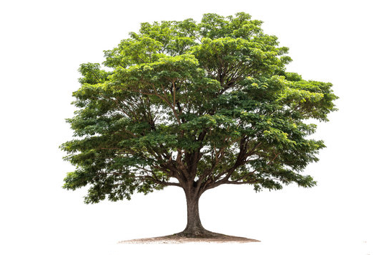

**Output:**

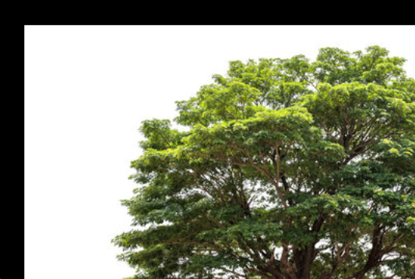

**Result:**

The python code to perform transformation using direct linear transformation on an input image has been executed successfully.